EENG 385 - Electronic Devices and Circuits

BJT Curve Tracer: Calibration

Lab Document

**Objective**

The objective of the lab is to introduce the behavior of a transistor and how the how the BJT curve tracer draws the family of *Ic vs. Vce* curves on an oscilloscope in X/Y mode. Finally, we wil calibrate the BJT curve tracer in order to quantify the information displayed on the oscilloscope.

# Assemble the BJT Curve Tracer

This week, you will be soldering in the components in the upper right corner of the BJT Curve Tracer PCB, completing the assembly as shown in Figure 8.

* You will need two 2N3906 PNP transistors to populate the Q5 and Q6 positions. Make sure the flat side of the PNP package aligns with the flat side of the PCB silkscreen.
* You will need one 2N3904 to populate the Q2 position in the ST Relax Oscillator area. Make sure the flat side of the PNP package aligns with the flat side of the PCB silkscreen.
* You will need to use the 3-pin header included in your parts bag for the DUT.
* Save the leads from your resistors to solder in the CH_X, XH_Y and GNG loops

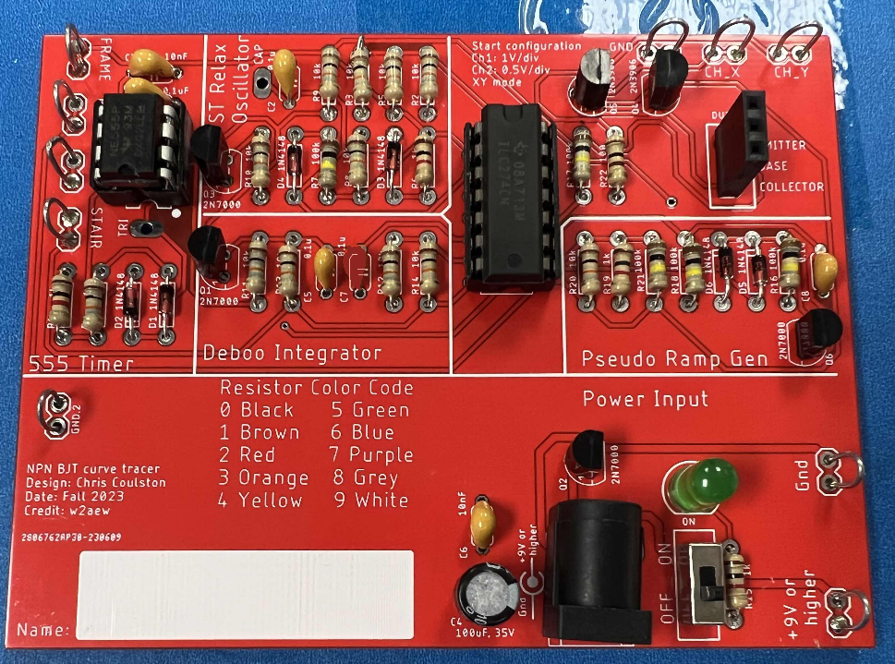

Figure : The completed BJT Curve Tracer board. Your value of R17 should be between 220k and 470k.

Once you have completed soldering in the new components you will notice the amplitude of the FRAME output will drop. The 555PULSE, STAIR, and Pseudo Ramp outputs should be unchanged. Now, test your completed BJT Curve Tracer and get some data.

# Tips For Top Performance

# 1) Don’t assume that the specified component values are correct. Measure the 100Ω and 100kΩ resistors with a DMM before installing them into the PCB. Use the measured values of these resistors in the Vce and Ib tables.

2) Match the pair of 2N3906 BJTs that form the current mirror in the output stage. At a minimum make sure that the BJTs are from the same lot. You can do this using the Peak Atlas DCA Pro that is available from the instructor.

For example, the two PNP BJTs resulted in

|  |  |  |
| --- | --- | --- |
| 2N3906 Marking |  | Gain at 10uA |
| 2N  3906  H 311 |  | 165 |
| F830  2N  3906 |  | 162 |
| S 3906 2N |  | 238 |
| 2N  3906  H 311 |  | 228 |
| 2N  3906  H 311 |  | 210 |

# Inserting the DUT into the BJT Curve Tracer

You will be measuring the performance of several BJTs in this week’s lab. In order to do so, you will have to insert the leads of the BJT into the correct socket positions as shown in Figure 9C. I orientated the DUT socket with the 2N3904 and 2N2222 BJTs in mind. To see how that effected the design, look closely at the arrangement of pins in Figure 9A and 7B. Even though the pins are arranged differently, the base is the center pin.

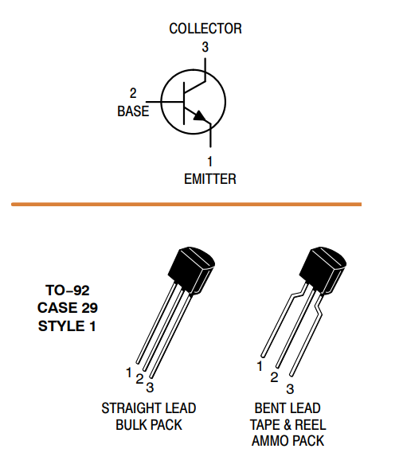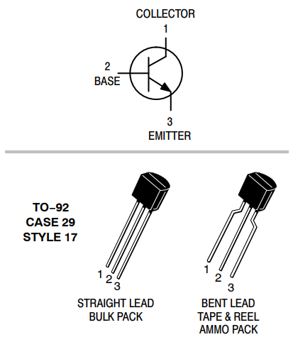 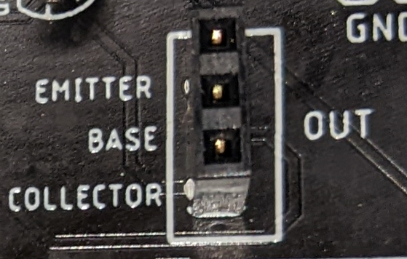

1. (B) (C)

Figure : (A) The datasheet for the 2N3904. (B) The datasheet for the 2N2222. (C) The socket for the DUT.

So you have to insert the 2N3904 into the DUT socket so that the BJT’s flat side is facing left. However, you have to insert the 2N2222 into the DUT socket so that the BJT’s flat side is facing right. You will not harm the test BJT if you put it in backwards.

The BJTs shown in Figure 9A and B are encased in JEDEC standard Transistor Outline Package Case Style 92 or TO-92 package. Most BJTs in a TO-92 package have the base as their center pin. This situation makes inserting them into the DUT socket a matter of trying two different orientations. The situation gets more complex for larger packages.

Before continuing, a note about BJT datasheets. Often BJTs are developed in complementary NPN/PNP pairs. For instance, Motorola designed 2N3904 and 2N3906 BJTs. Being designed as complementary pairs, the manufacturers often group the two complementary BJTs on the same datasheet for efficiency. When the manufacturer does this, you only need to look at the NPN device parameters datasheet because you will only be testing NPN devices in the BJT Curve Tracer.

Now, look at the datasheet for the BD139 and TIP41C shown in Figure 10A and 8B.

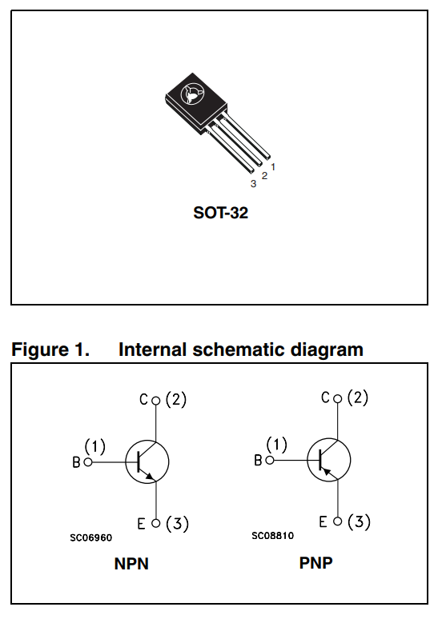 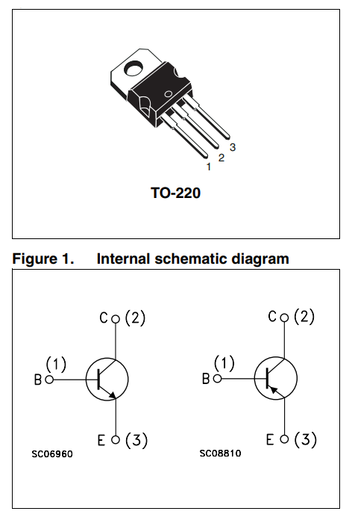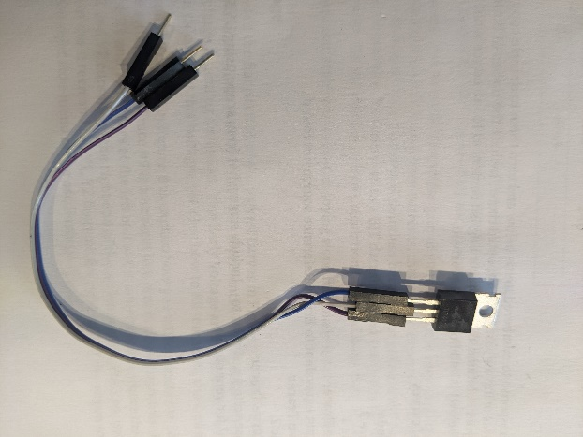

(A) (B) (C)

Figure : (A) The pinout for the BD139 (NPN) and BD140 (PNP). The pinout of the TIP41C (NPN) and TIP42C (PNP). You can use a set of jumper wires to adapt the pins of non-conforming devices to the DUT socket.

In Figure 10A, the NPN device in the Internal Schematic Diagram frame is called out as “NPN”. The base of the schematic symbol is denoted “B” with an accompanying number (1). Looking at the physical package above the schematic, the pin labeled “1” is the base, the rightmost pin on the BD139 when viewed from the front. In Figure 10B, the datasheet does not explicitly tell you which device is NPN, you need to look for its correct schematic symbol (SC06960). You should see the base is on the left side of the package when viewed from the front.

In both cases, you will need to reposition the BJT’s package leads before connecting it to the DUT socket on the BJT Curve Tracer. Do not bend the leads to accomplish this. By doing so, you risk breaking the leads, shorting the leads together, and making you look like a hack – a bad look. Instead, connect 3 male/female jumper wires as shown in Figure 10C to the BJT and then connect the male ends of the leads to the DUT socket.